**Online Education Employment (Android) Project**

**Design Specifications**

Version: 1.0

Date: 20 Aug. 2015

Document Modification History/Revision log

|  |  |  |  |
| --- | --- | --- | --- |
| Version | Date | Author | Description of Change |
| 1.0 | 20/08/2015 | VEL team | Initial version |
|  |  |  |  |
|  |  |  |  |
|  |  |  |  |
|  |  |  |  |

Contents

1. Software Architecture and Design 3

1.1. Architecture Diagram 3

1.2. Class Diagram 3

2. Design Decisions 4

2.1. Product Backlog 4

2.2. Sprint Backlog 4

3. Low Fi Prototypes 4

3.1. Client Meeting Plan 4

3.2. Team Meeting Plan 4

# Software Architecture and Design

## Architecture Diagram

This website uses a 3-tier architecture, where presentation layer, business logic layer and database layer can be easily developed and maintained separately. Communication and data exchange between server and browser will be implemented using web service APIs, which allows high level decoupling and produce flexibility without introducing complexity into the system.

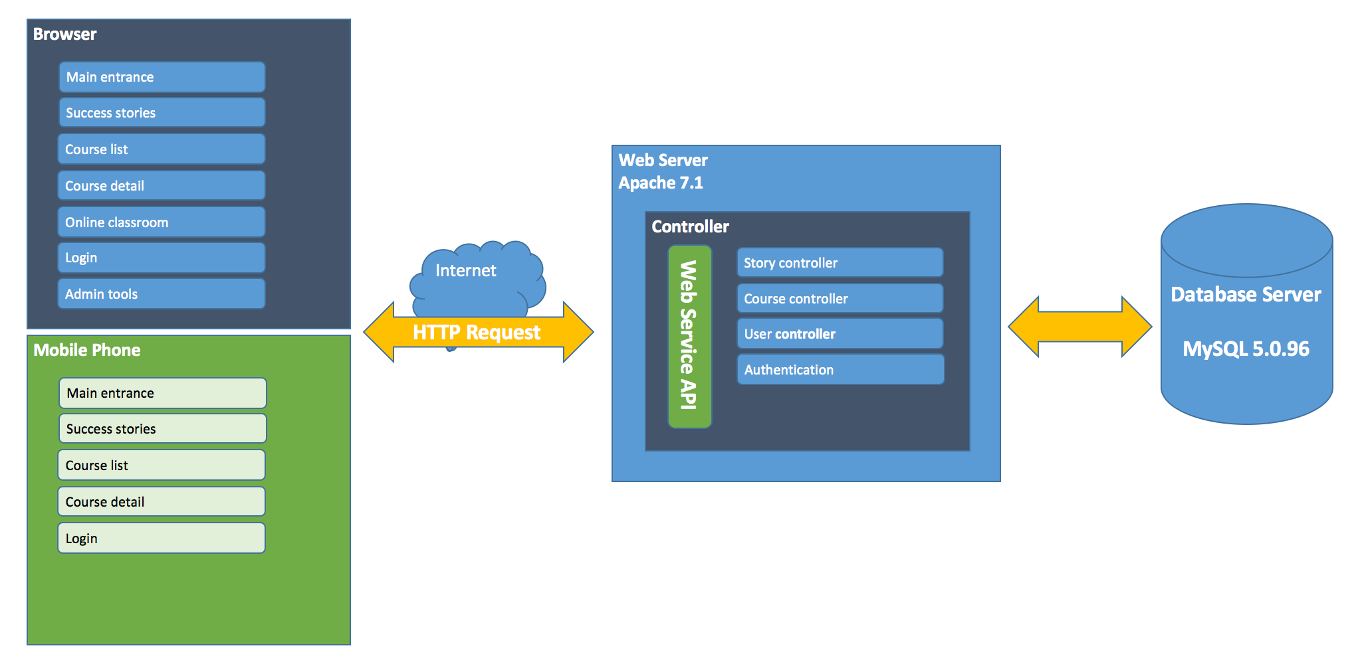

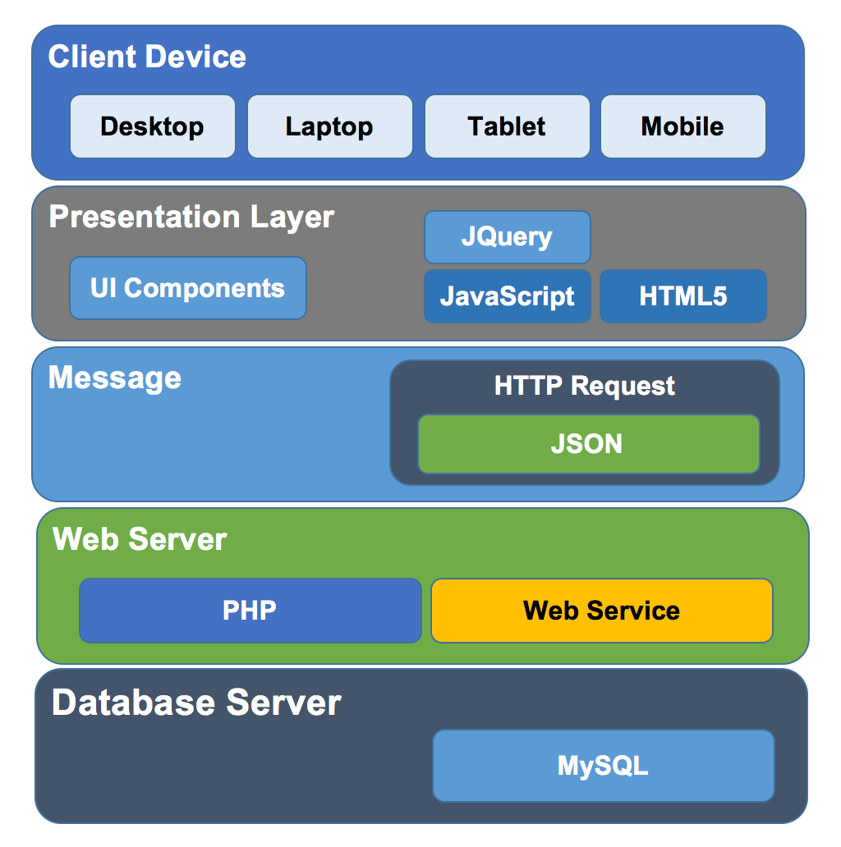

## Class Diagram

# Design Decisions



## Product Backlog

## Sprint Backlog

This is the Sprint Backlog for the first Sprint, which will start from 17 August to 30 August, 2015. According to the product backlog which is prioritized by customers, they value more about the self- adaptability and basic functions of the website. Considering there is no conflict between these two aspects, in the coming sprint, the team will focus on the user stories list here.

# Low Fi Prototypes



## Client Meeting Plan

The available time of Client Meeting, at client’s office are as following.

## Team Meeting Plan

Team internal communication plan defined as below: